1. **z`**

A Project Report On

**YouTube Clone**

Bachelor of Computer Application

BCA

Academic Year 2025 – 26

**Parmar Jalpit : 92300527105**

**Jadeja Bhagyarajsinh : 92300527032**



# **YouTube Clone Project Details**

## ****Synopsis****

The YouTube Clone Web Application is a PHP–MySQL based video sharing platform that allows users to upload, watch, like, comment, and subscribe to video content. The system mimics core functionalities of YouTube while maintaining a simplified and academic-oriented architecture.

The platform includes user authentication, video management, interaction features such as likes, comments, subscriptions, reporting, and advertisement handling. An admin panel controls content moderation and user management to ensure platform integrity.

## ****Project Description****

### The YouTube Clone project is developed using PHP for backend logic and MySQL for database management. It provides a user-friendly interface for content creators and viewers. Users can upload videos, manage their channel, and interact with other users’ content.

### The system supports role-based access where administrators have elevated privileges for managing reports, ads, and users.

### Modules Description

**1.Admin Module**

### • Manage users and assign admin roles • Monitor uploaded videos • Manage reported content • Handle advertisements

**2.User Module**

### • User registration and login • Upload, edit, and delete videos • Like and comment on videos • Subscribe to channels • Report inappropriate videos

### ****Database Overview****

The database 'youtube_clone' contains the following tables:  
  
• user – stores user information  
• video – stores uploaded videos  
• likes – tracks video likes  
• comment – stores comments  
• subscribe – manages channel subscriptions  
• report – handles reported videos  
• ads – stores advertisement data

**Flow chart :**

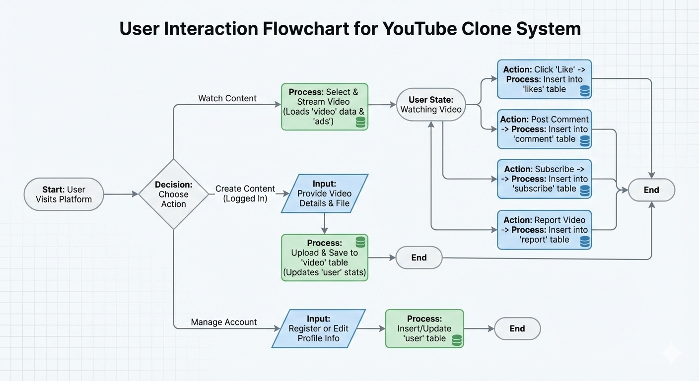

**FLOW CHART OF YouTube Clone**

**USE CASE DIAGRAM:**

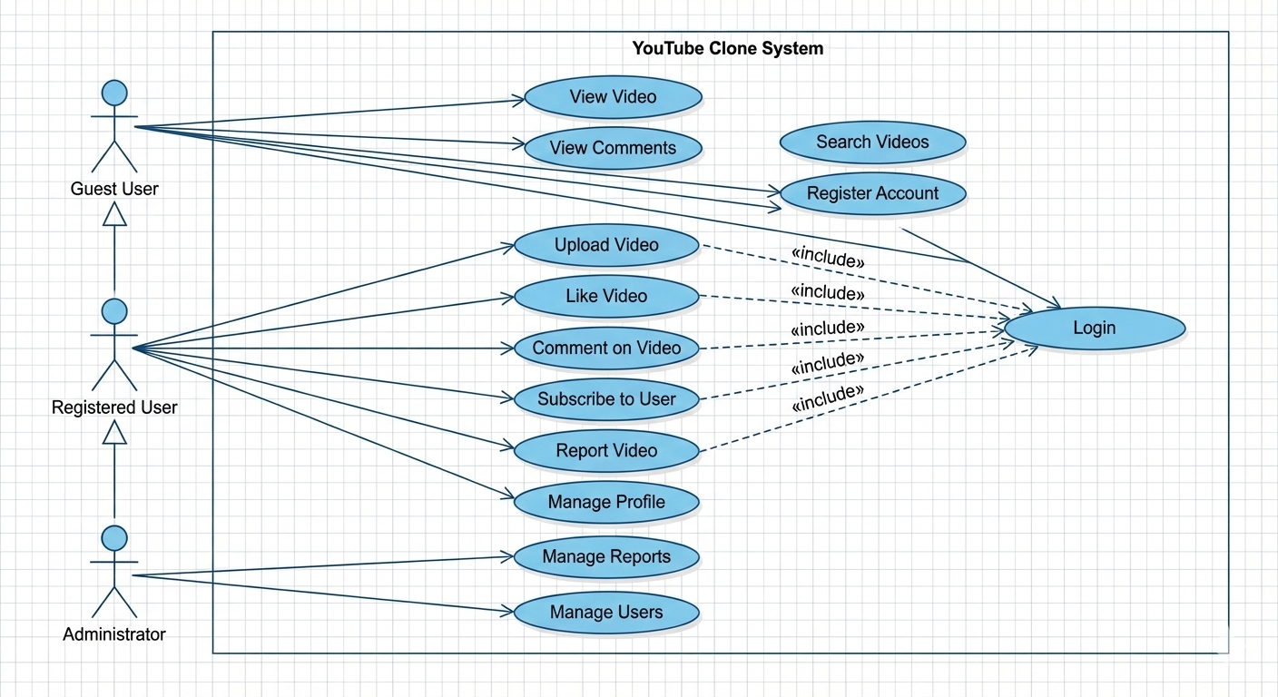

**USE CASE DIAGRAM OF YouTube Clone**

**CLASS DIAGRAM :**

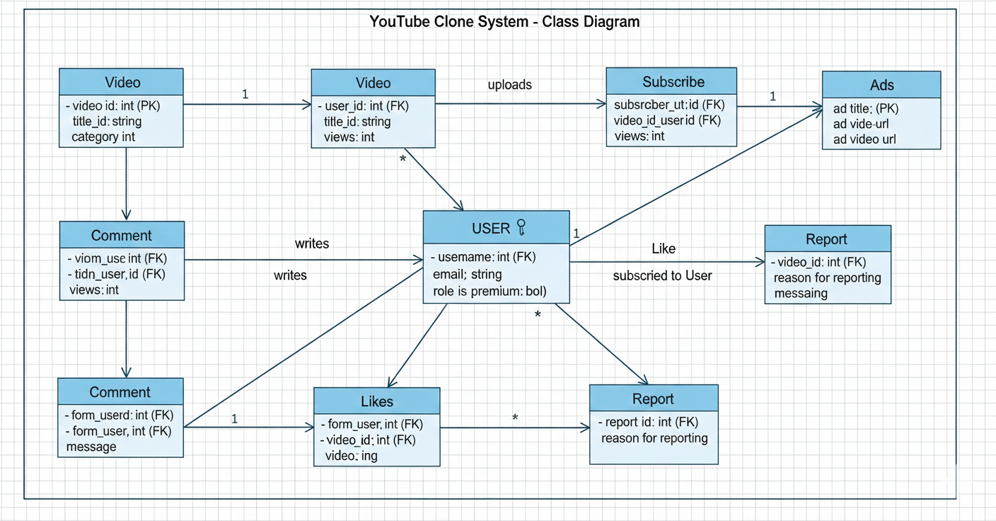

**CLASS DIAGRAM OF YouTube Clone**

**ACTIVITY DIAGRAM :**

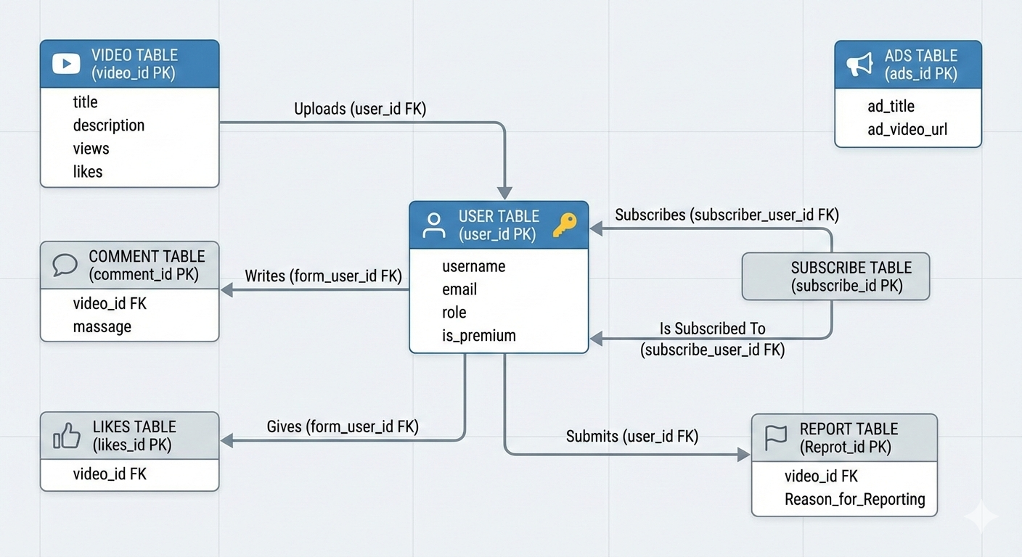

**ACTIVITY DIAGRAM OF YouTube Clone**

**DATABASE DESIGN DIAGRAM :**

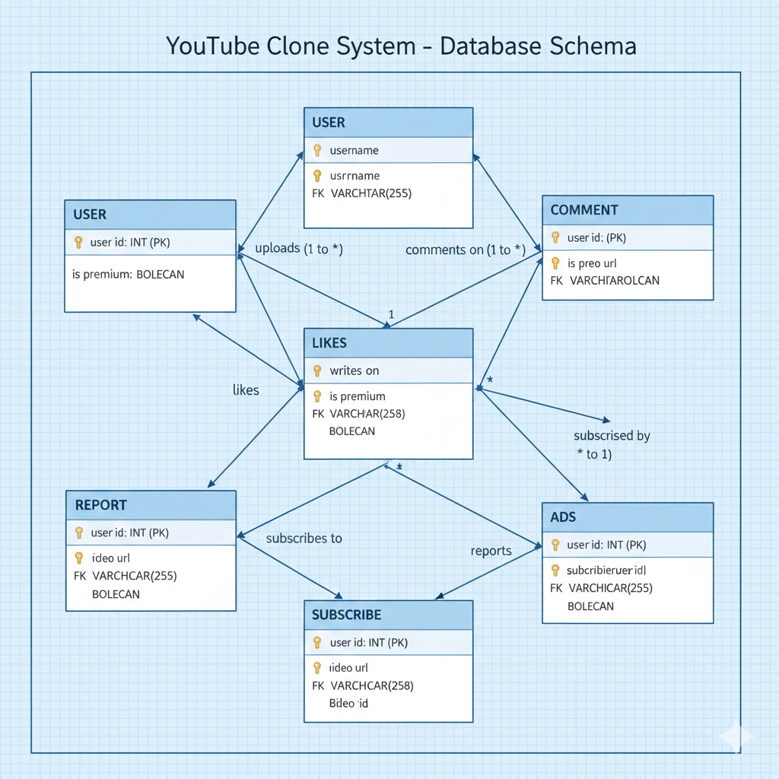

**DATABASE DESIGN DIAGRAM OF YouTube Clone**

**GUI Designs:**

**Login page:**

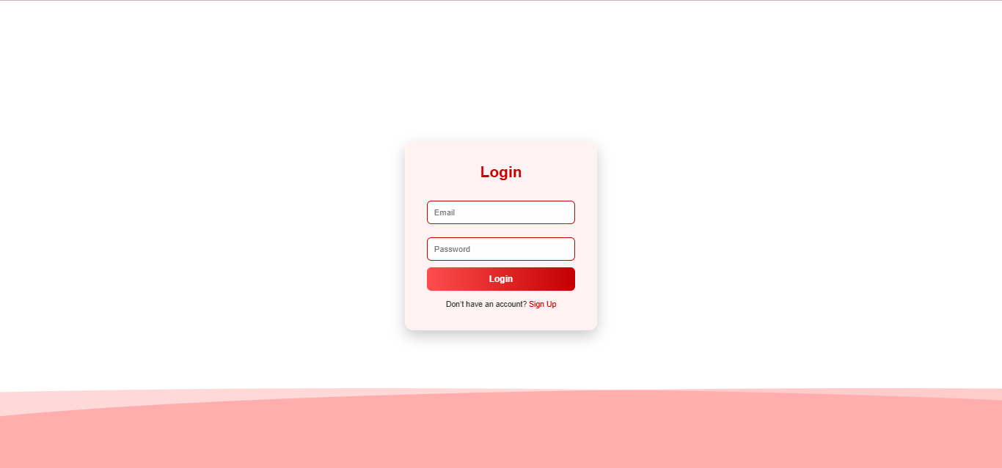

**Signup page:**

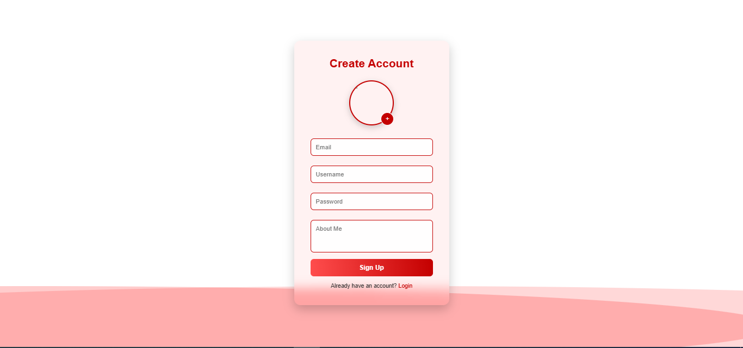

**Home page:**

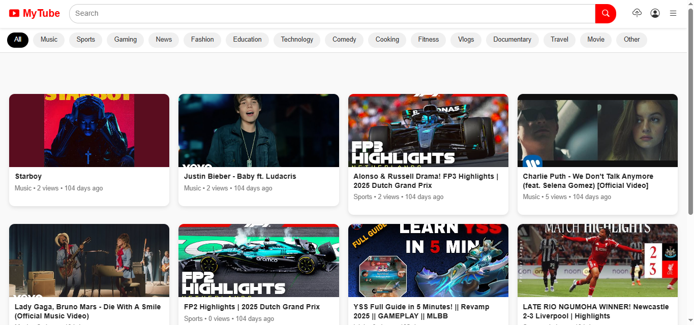

**Profile page:**

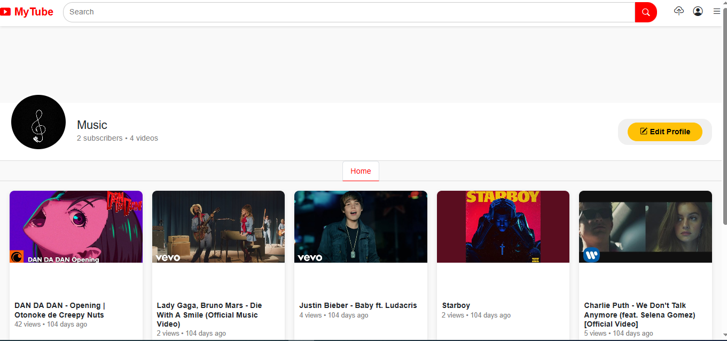

**View page:**

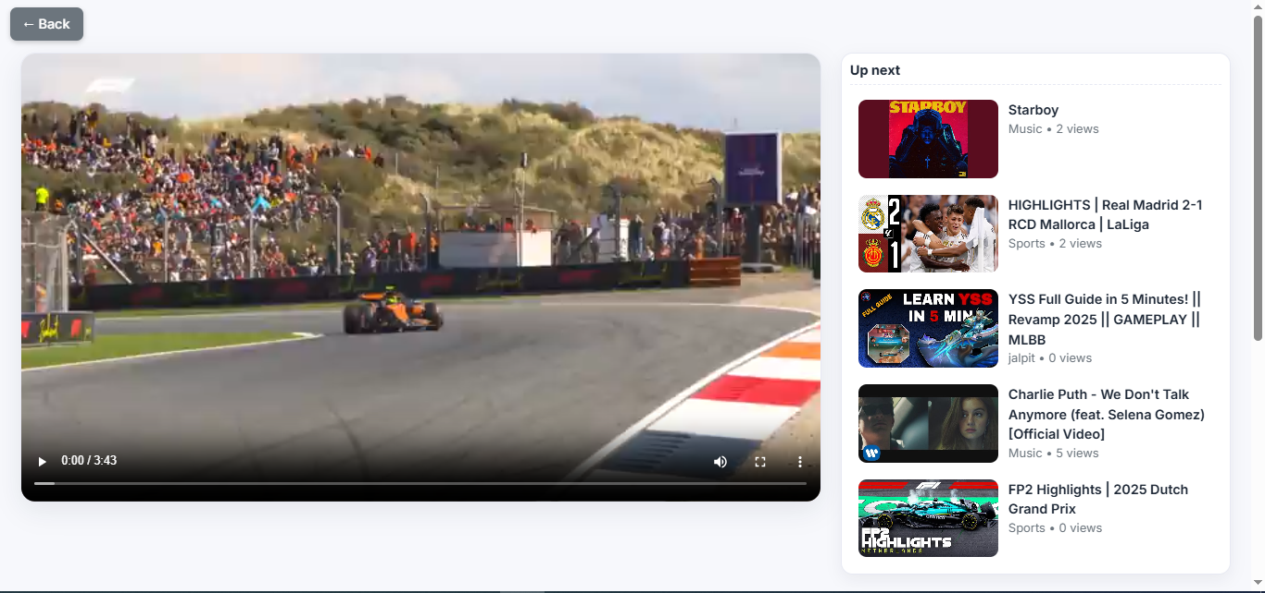

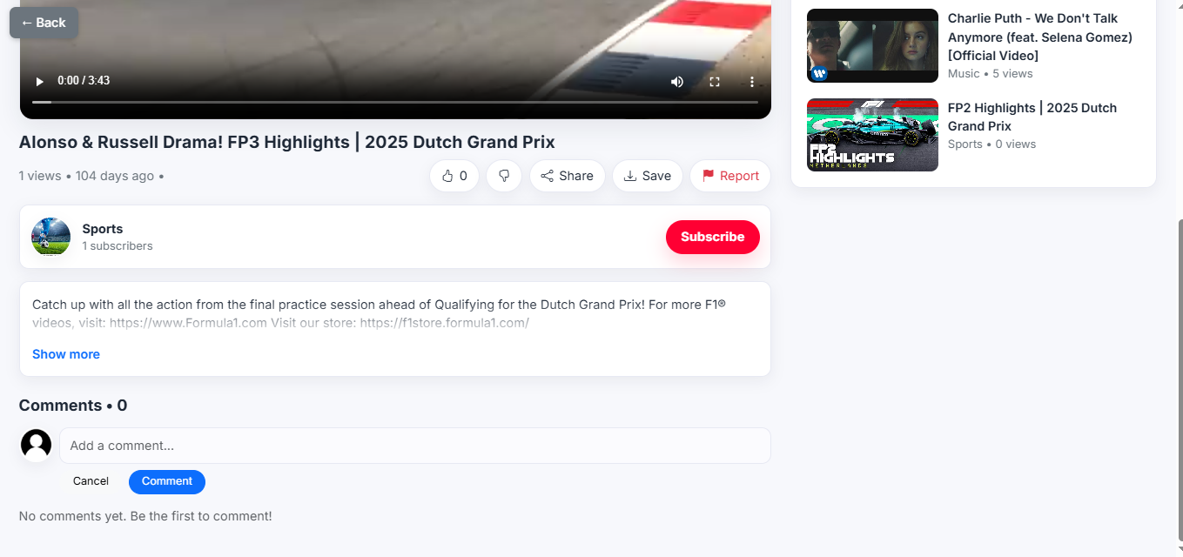

**Upload page:**

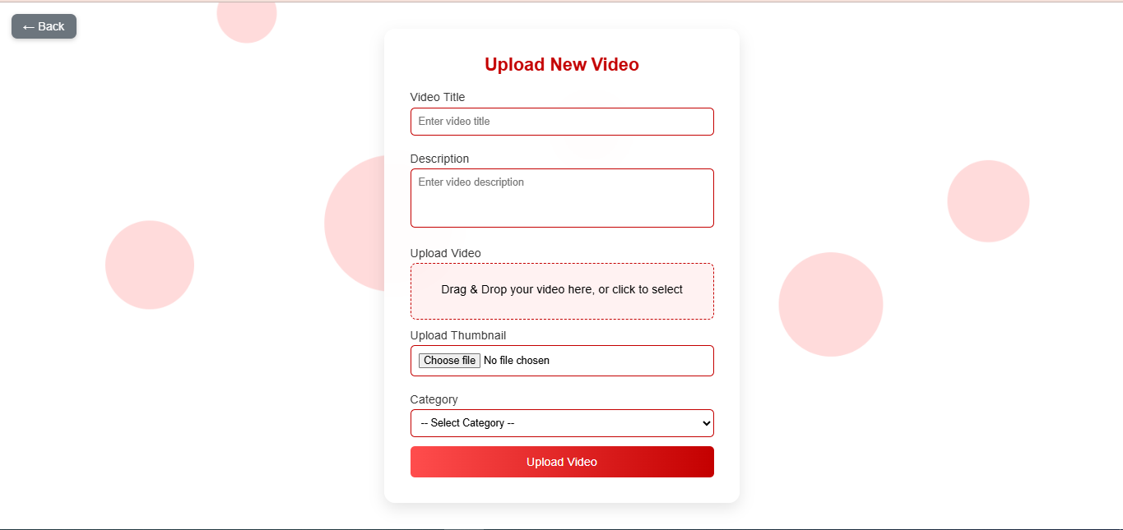

**Watch History page:**

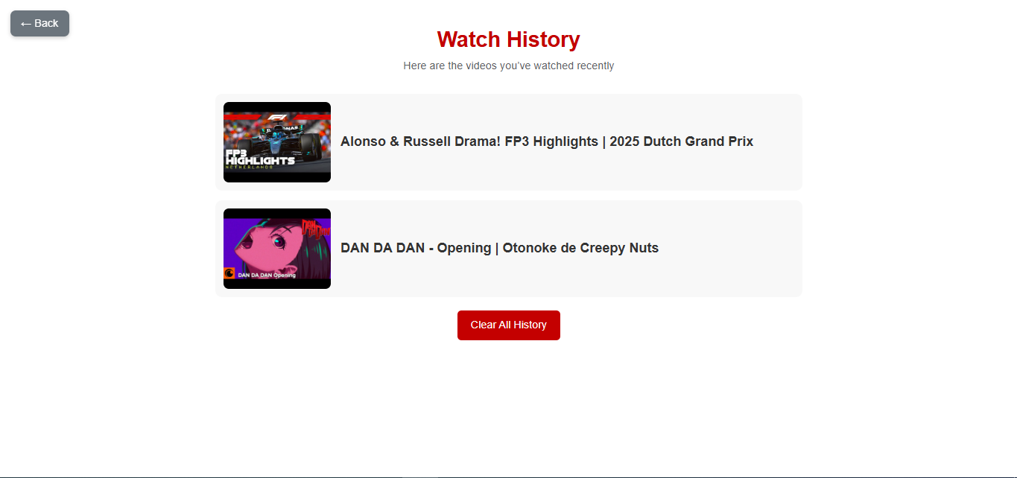

**Manage Ad’s page:**

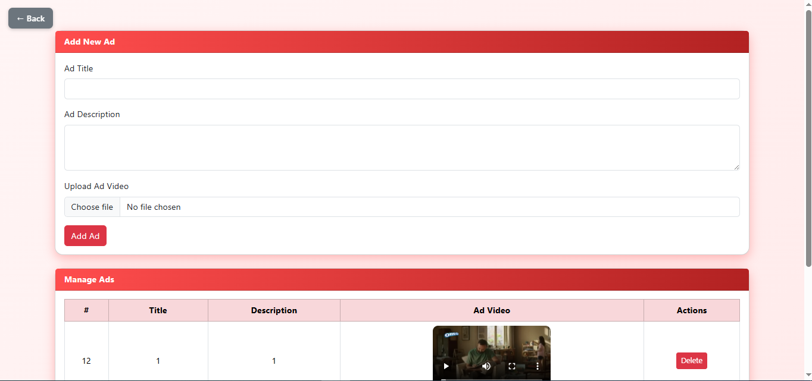

**Manage Reports page:**

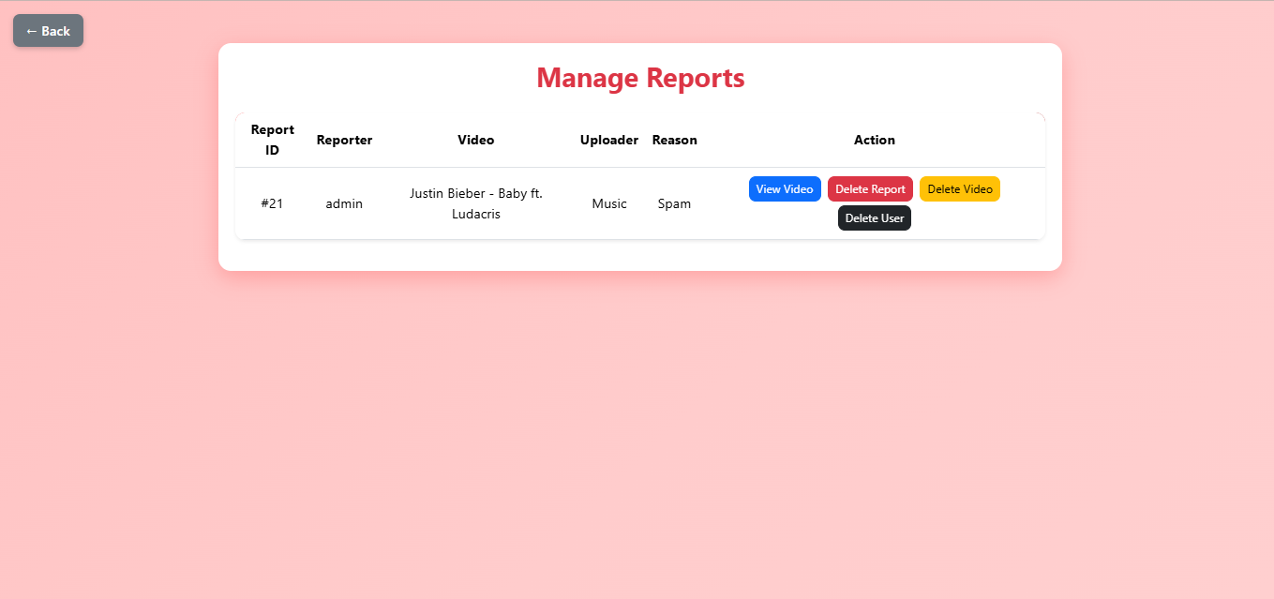

**Manage videos page:**

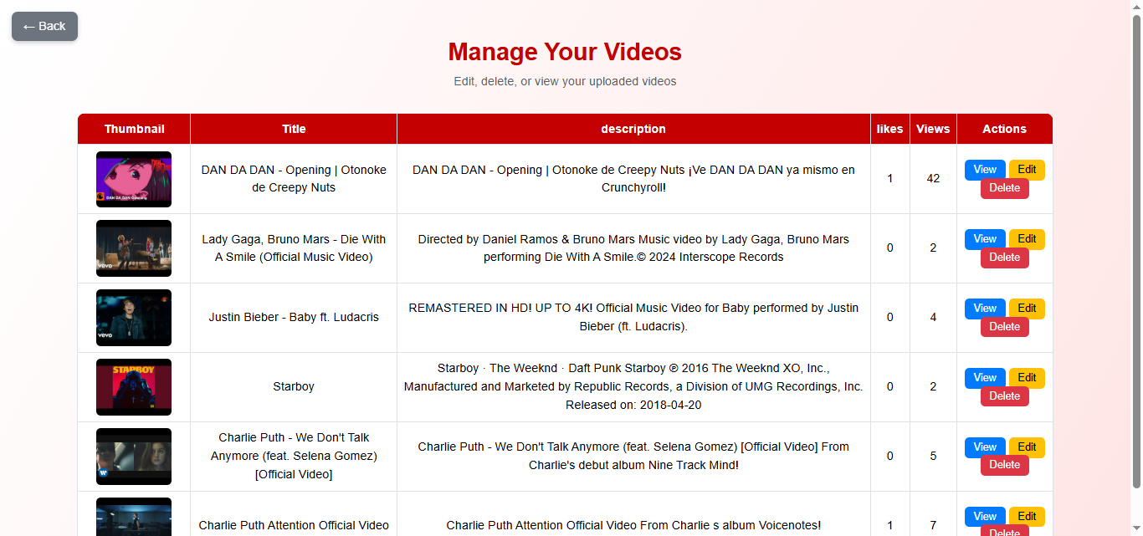

**Buy Premium page:**

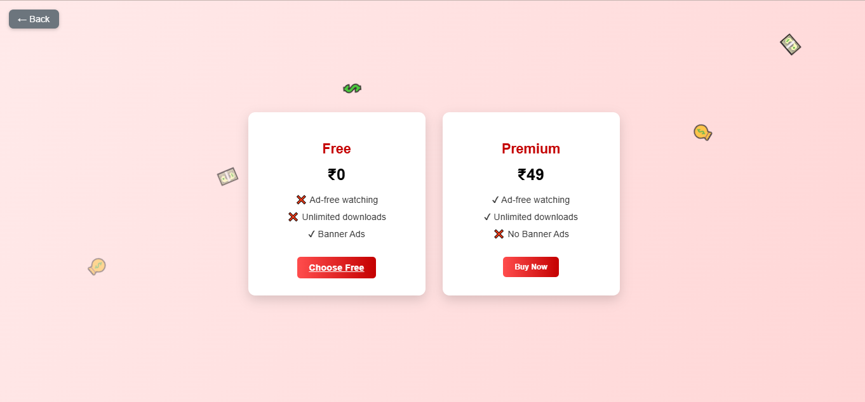

**Subscriped page:**

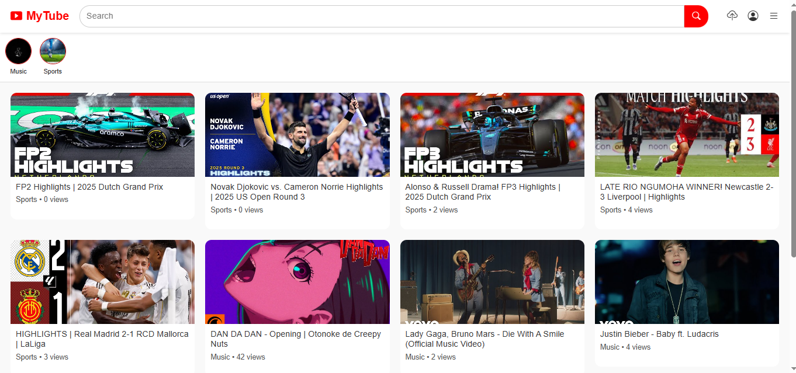

**Database Structure**

**Database Name: youtube_clone**

**1. user Table**

**The user table stores all registered user details.**

**Purpose:**

**User authentication**

**Role management (Admin/User)**

**Channel information**

**Main Fields:**

**user_id – Unique user identifier**

**username – User’s display name**

**email – Registered email address**

**password – Encrypted password**

**about – User channel description**

**dp_url – Profile picture path**

**role – User or Admin**

**is_premium – Premium status**

**subscribers – Subscriber count**

**videos_uploaded – Total uploaded videos**

**created_at – Account creation date**

**2. video Table**

**The video table stores information related to uploaded videos.**

**Purpose:**

**Manage video content**

**Display videos to users**

**Main Fields:**

**video_id – Unique video ID**

**user_id – Video uploader ID**

**title – Video title**

**description – Video description**

**category – Video category**

**thumbnail_url – Thumbnail image path**

**video_url – Video file path**

**views – Number of views**

**likes – Like count**

**time – Upload timestamp**

**username – Uploader username**

**3. likes Table**

**The likes table stores user likes on videos.**

**Purpose:**

**Track which user liked which video**

**Main Fields:**

**likes_id – Like ID**

**form_user_id – User who liked**

**to_user_id – Video owner**

**video_id – Liked video ID**

**4. comment Table**

**The comment table stores comments posted on videos.**

**Purpose:**

**Manage user comments**

**Main Fields:**

**comment_id – Comment ID**

**form_username – Commenter name**

**form_user_id – Commenter ID**

**to_use_id – Video owner ID**

**video_id – Video ID**

**massage – Comment text**

**5. subscribe Table**

**The subscribe table manages channel subscriptions.**

**Purpose:**

**Track user subscriptions**

**Main Fields:**

**subscribe_id – Subscription ID**

**subscriber_user_id – Subscriber**

**subscribe_user_id – Channel owner**

**6. report Table**

**The report table stores reports submitted by users.**

**Purpose:**

**Content moderation**

**Main Fields:**

**Reprot_id – Report ID**

**video_id – Reported video**

**user_id – Reporting user**

**Reason_for_Reporting – Reason**

**Additional_Details – Extra information**

**7. ads Table**

**The ads table stores advertisement details.**

**Purpose:**

**Manage video advertisements**

**Main Fields:**

**ads_id – Advertisement ID**

**ad_title – Advertisement title**

**ad_video_url – Advertisement video**

**ad_link – Redirect link**